KEY TOOLS PORTFOLIO FOR SERVITIZATION OF CE PRODUCT-BASED MANUFACTURING COMPANIES

PhaseS 3,4 & 5 - revised

|  |  |
| --- | --- |
| **D.T3.2.5** | **Version 1**  **3 2019** |

THINGS+

Introducing service innovation into product-based manufacturing companies

01.06.2017 - 31.05.2020

Project number: CE 988

Interreg Central Europe Programme

|  |  |  |  |  |  |
| --- | --- | --- | --- | --- | --- |
| Work package | T3 | Activity | A.T3.2 | Deliverable | D.T3.2.5 |
| Date | March 26th 2019 | | | Due date | March 2019[1] |
| Title | Key tools portfolio for servitization of CE product-based manufacturing companies – Phase 3, 4 & 5 | | | | |
| Project Partner responsible | All partners | | | | |
| Report Status (DR = Draft, FI = Final) | | | | FI | |
| THINGS+ website | http://www.interreg-central.eu/Content.Node/THINGS-.html | | | | |

Contents

1. Phase 3: Change and implementation design 2

1.1. Business Model Canvas 4

1.2. Resources Processes and Values Framework – extended with trends, change requirements and expected results 6

2. Phase 4: Product servitization implementation and commercialisation 9

2.1. One Page Strategy 11

2.2. List of Assumptions 13

2.3. Implementation activities 15

3. Phase 5: Product servitization implementation - international 17

1. Phase 3: Change and implementation design

The first part of this document contains a set of tools to be used during the third phase of implementing the Service Innovation Methodology. These tools are used to design and envision the new state, servitization elements and also to plan the change. Phase 3 is much less prescriptive and suggested steps are supposed to create platform at which each company will build the implementation project according to their particular management habits and capabilities.

Third phase tools should support companies during the process of designing the servitization project and understanding the changes that the company (business model, organization and capabilities in general) will face.

Tools will be used to briefly identify main challenges and to create the service blueprint during the workshop (or 1on1 consulting). It is expected that companies will follow up with detailed elaboration during homework (level of company’s effort and engagement in certain tasks can vary as a result of different management and organizational habits).

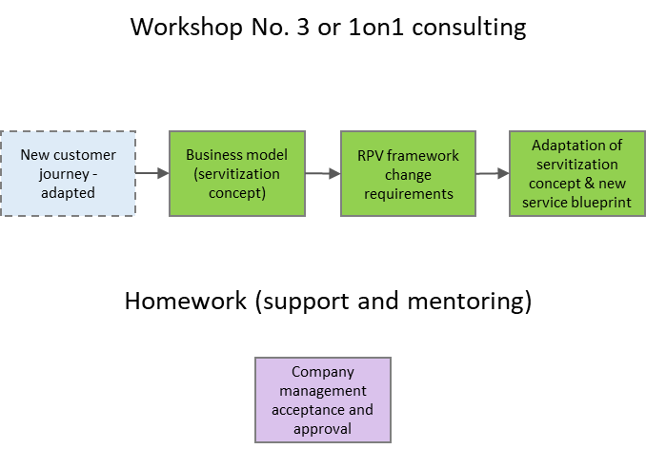

Figure 1 Workflow of the third phase of the Service Innovation Methodology

* 1. Business Model Canvas

|  |  |
| --- | --- |
| **Business Model Canvas is used as a checklist for identifying key elements of the business model – the rationale of creating, delivering and capturing value. Key aim is description of existing BM and identification of the elements that will be changed or added.** | |
| **Guidelines on implementation:** | **D.T1.3.1 - Phase 3 – Workshop** |

The Business Model Canvas is a tool used for developing new or documenting existing business models. It is a visual chart with elements describing a firm's value proposition, infrastructure, customers, and finances. It assists firms in aligning their activities by illustrating potential trade-offs.

Canvas can be used to describe, design, challenge, and pivot the business model. It works in conjunction with the Value Proposition Canvas and other strategic management and execution tools and processes. The Business Model Canvas was initially proposed by Alexander Osterwalder based on his earlier work on Business Model Ontology. Osterwalder's work and thesis propose a single reference model based on the similarities of a wide range of business model conceptualizations. With his business model design template, an enterprise can easily describe their business model.

The Canvas is popular with entrepreneurs for business model innovation. Fundamentally, it delivers three things:

* Focus: users of the BMC improve their focus on what’s driving the business (and what’s non-core and getting in the way)
* Flexibility: it’s a lot easier to tweak the model and try things (from a planning perspective) with something that’s sitting on a single page
* Transparency: it is much easier understanding the business model and be much more likely to buy in to the vision when it’s laid out on a single page.

The Business Model Canvas can be printed out on a large surface so groups of people can jointly start sketching and discussing business model elements with post-it notes or board markers. It is a hands-on tool that fosters understanding, discussion, creativity, and analysis. It is distributed under a Creative Commons license from Strategyzer AG and can be used without any restrictions for modelling businesses.

The Business Model Canvas is also available in web-based software format.

|  |  |
| --- | --- |
| **Additional sources:** | * Stickdorn, M.; Schnaider, J.; et al.: This is service design thinking, John Wiley & Sons, Hoboken, New Jersey, 2011 * https://strategyzer.com/canvas/business-model-canvas * http://thetoolkitproject.com/tool/business-model-canvas#sthash.Yi3aD81z.dpbs * https://en.wikipedia.org/wiki/Business_Model_Canvas#Application * https://strategyzer.com/books/business-model-generation * https://www.youtube.com/user/businessmodeltv/featured |

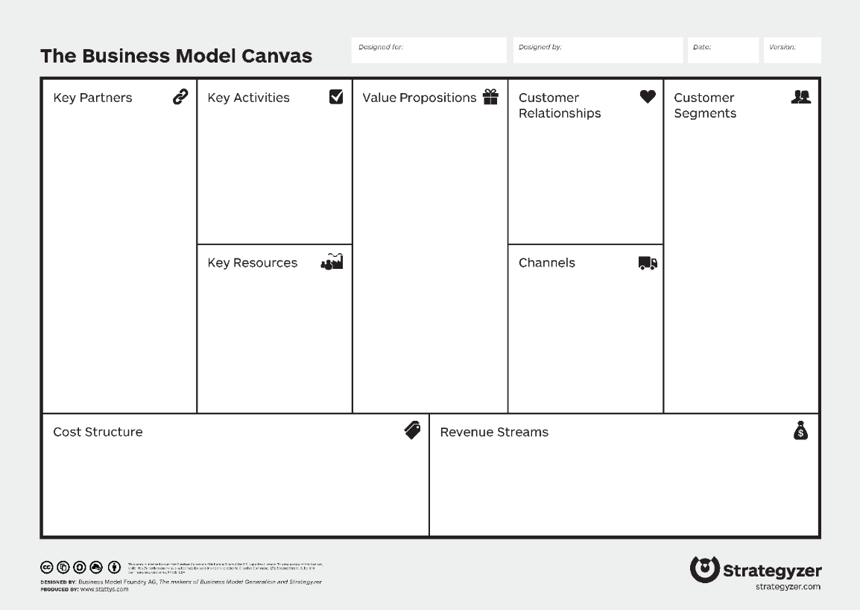

Figure 2 Example of the Business Model Canvas (source: strategyzer.com)

* 1. Resources Processes and Values Framework – extended with trends, change requirements and expected results

|  |  |
| --- | --- |
| **RPV framework should be elaborated and assessed through perspective of change that is envisioned. Companies should perform initial snapshot of the its resources, processes and values. Key aim is to define which elements will change and describe the change and expected results. Additional insight regarding trends and outside forces is suggested but optional.** | |
| **Guidelines on implementation:** | **D.T1.3.1 - Phase 3 – Workshop** |

RPV framework (Resource-Process-Value) is a tool used when confronted with necessary change to understand whether the organization is capable or incapable of tackling the challenge and implement innovation. More detailed description of the tool can be found in *Key tools portfolio for servitization of CE product-based manufacturing companies - Phase 1*.

Three classes of factors affect what an organization can and cannot do: its resources, its processes, and its values. When asking what sorts of innovations their organizations are and are not likely to be able to implement successfully, it can be learned a lot about capabilities by sorting the answers into these three categories. Summary of elements forming these three factors is provided in the table below and could help with evaluation of each segment to see if there is a possibility for changing the business model and introduction of added value to the proposition via service.

|  |  |  |
| --- | --- | --- |
| Term | Definition | What to look for |
| Resources | Things company has access to - that can buy or sell, build or destroy | * Tangible assets: People, technology, products, balance sheet, equipment, distribution network * Intangible assets: Human capital (employees’ background, accumulated skills), brands, accumulated knowledge |
| Processes | Way of doing business (skills) – established ways companies turn resources into products or services | * Difficult problems we know the company has repeatedly solved over time * Typical processes: Hiring and training, product development, manufacturing, planning and budgeting, market research, resource allocation |
| Values | Prioritization determinant (motivation) – the criteria by which prioritization decisions are made | * Business model: * Way a company makes money (e.g., mix of sales revenue to postsales service revenue) * Cost structure * Size and growth expectations * History of investment decisions – what has been prioritized in the past |

|  |  |
| --- | --- |
| **Additional sources:** | * Christensen, M. C.; Anthony, S.D.; Roth, E.A.: Seeing what’s next, Harvard Business School Publishing Coorporation, Boston, Massachusetts, USA, 2004 * Christensen, Clayton M. "Assessing Your Organization's Innovation Capabilities." Leader to Leader, no. 21 (summer 2001): 27–37. |

|  |  |  |
| --- | --- | --- |
|  | **Changes and transformations** | **Expected results** |
| **Resources**  Things company has access to - that can buy or sell, build or destroy, tangible or intangible |  |  |
| **Processes**  Way of doing business (skills) – established ways companies turn resources into products or services |  |  |
| **Values**  Prioritization determinant (motivation) – the criteria by which prioritization decisions are made |  |  |

1. Phase 4: Product servitization implementation and commercialisation

This chapter contains a set of tools to be used during the fourth phase of the servitization process, which focuses on the commercialisation of the servitized product. Based on the results of previous activities and the elaborated servitization concept, the implementation strategy will be formulated and elements of the servitization initiative should be incorporated into the company’s strategic management activities. For this purpose, two tools will be used simultaneously, the One Page Strategy and the List of Assumptions. Elaborated One Page Strategy and List of Assumption can be additionally supplemented by Implementation activities description form (optional). After their creation and elaboration, these documents will represent the “Servitization implementation plan”.

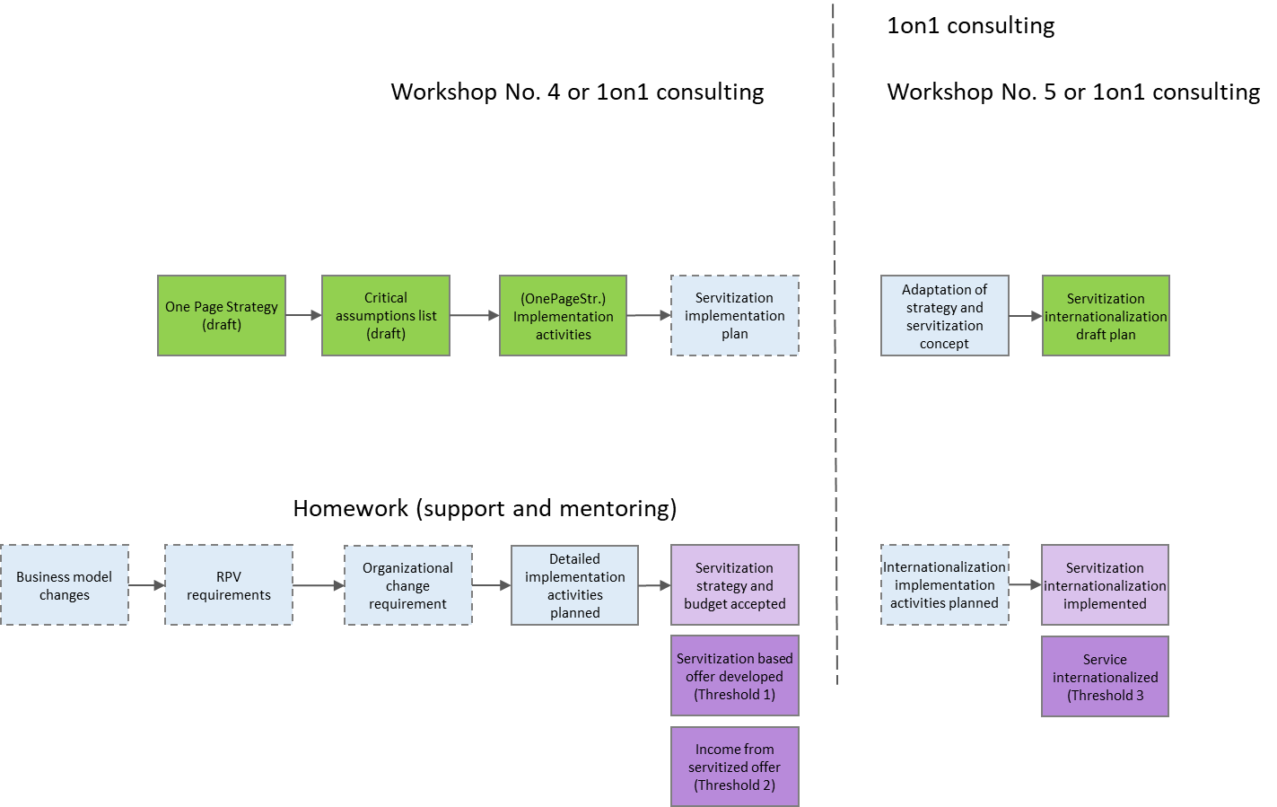

Figure 3 Workflow of the fourth and fifth phase of the Service Innovation Methodology

* 1. One Page Strategy

|  |  |
| --- | --- |
| **Since servitization initiatives might have impact on many aspects of company performance, some kind of strategy alignment is important. In order to avoid too complex planning and decision-making procedure, One Page Strategy is proposed as a simple yet powerful strategy management tool.**  **It should enable seamless implementation of servitization initiative and its integration into broader, already existing strategy.** | |
| **Guidelines on implementation:** | **D.T1.3.1 - Phase 4 – Workshop** |

One Page Strategy is an effective way of creating a strategic plan which is short (one page), clear, simple, feasible and measurable. The process of drafting the One Page Strategy is also applicable when planning projects and developing strategies for workgroups, departments, small businesses, crafts or associations.

The process of creating the One Page Strategy is based on two simple questions: What? and How?, respectively "What is Success?" and "How Do We Realize It?". The canvas for the One Page Strategy is composed of two main sections intended to be filled up with references that provide answers to these questions. The section concerning What? contains blocks concerning Success and Goals, while section concerning How? contains blocks concerning Strategies and Activities.

One Page Strategy is an effective way of making a strategic plan that is:

* short - on just one page
* clear and simple - easy to understand, explain and see the link between the plan and the activity
* feasible and measurable - each implementation activity has a responsible person, deadline and result indicator.

The process implies making some tough decisions: to limit the description of success in one sentence, to choose a few key goals, to list what we have to do and what we will not do, all with the aim of being focused on those ideas, jobs and strategies that bring success.

|  |  |
| --- | --- |
| **Additional sources:** | * http://www.step.uniri.hr/portfolio/strategija-na-a4/ * https://www.slideshare.net/dragon.hr/strategija-na-a4-predavanje-2009 |

|  |  |  |  |
| --- | --- | --- | --- |
| **Success**  1  **1** |  | **Strategies**  **3**  3 | **Activities** |
|  |
|  |
|  |
|  |
|  |  |
| **Strategic** **goals**  **2**  2 |  |
|  |
|  |
|  |
|  |

* 1. List of Assumptions

|  |  |
| --- | --- |
| **One result of the One Page Strategy is a great number of assumptions regarding environment, markets, customers but also organizational and individual capabilities. Management based on the assumptions allows swifter response and better adjustment which is more in line with the lean startup thinking (customer development process) than traditional, inert approach.** | |
| **Guidelines on implementation:** | **D.T1.3.1 - Phase 4 – Workshop** |

The following form can be used to describe and document the assumptions that are presumed during the elaboration of the strategy. The assumptions are built around the company’s environment, its capabilities and resources and persons responsible for particular actions and elements of the servitization process.

|  |  |  |
| --- | --- | --- |
| **Assumptions about:** | | |
| 1. **Environment** | **2. Company** | **3. People** |
|  |  |  |

* 1. Implementation activities

|  |  |
| --- | --- |
| **During or after the creation of the One Page Strategy and the List of Assumptions, further elaboration and documentation of tasks can be done for each implementation activity. These forms can be used for further elaboration of key implementation activities drafted in the One Page Strategy, and also to better communicate and delegate elaborated tasks within the company’s organizational structure.** | |
| **Guidelines on implementation:** | **D.T1.3.1 - Phase 4 – Workshop** |

The form provided can be used to document implementation activities in order to specify the workflow, responsibilities, needed resources, timeframe and expected results. Activities are documented by answering the following questions:

1. Short description: What is important and has to be done?
2. Who is responsible?
3. Which results are expected and how to track (measure) them?
4. Timeline and deadlines for targets?
5. Which resources are needed (and when)?

|  |  |
| --- | --- |
| **Strategy:** | **Activity:** |
| Activity description/rationale: | |
| Responsible person(s) | Expected results |
| Resources | Timeline/deadlines |

1. Phase 5: Product servitization implementation - international

The fourth and fifth phase of the servitization process are less prescriptive and case-specific. The experts have to adapt their approach to each SME, therefore 1 on 1 mentoring will be more often applied instead of group workshops, especially for the fifth phase. There are no specific tools suggested to be used for the internationalisation support during the fifth phase, as internationalisation activities can be already included in the commercialization strategy formed during the fourth phase. In case the internationalisation activities were not define in previous phase, the same tools (One Page Strategy, List of Assumptions and the Implementation activities description form) can be used with the focus only on internationalisation (transformation of distribution channels, workforce scalability, cultural specificities of the market and possible new technologies (ICT) implementation). This phase is based on individual interactions and additional internationalisation efforts made by the company.

1. The delivery month settled in the approved Application Form (February 2019) has been postponed upon decision of the Project Management Board to improve the quality of the deliverable. The delay did not have any negative effect on the project implementation.